Flikma Finance Entries
How every finance entry is saved, which tables it touches, and what the finance redesign changed
Status as of 13 October 2026. The same content is available live in the app at /finance-entries/workflow.
1. Big picture
2. How an entry is saved
3. Posting by document
Worked example
4. Settlement: invoice, receipt, credit note
5. Tables and how they relate
6. Which report reads what
7. What was done in the finance redesign
8. Known gaps and open decisions
9. Commands

1. Big picture
Every approved document is turned into one balanced journal entry: a header row in finance and its debit and credit lines in finance_subs. Reports, settlements and job totals are all derived from that journal. The direction is one-way: document, then journal, then everything else.
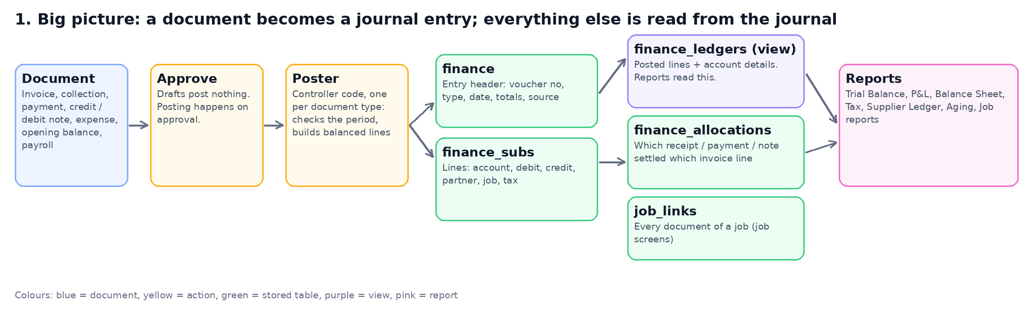
- Drafts post nothing. Posting happens when the document is approved (opening balances post when saved).
- finance and finance_subs together are the double-entry ledger. finance_ledgers is only a read-only view over them, not a copy.
- finance_allocations records which receipt, payment or credit note settled which invoice.

2. How an entry is saved
The steps are the same for every document type. Today each document type has its own copy of this code in its controller (eight places); the redesign plans a single PostingService.
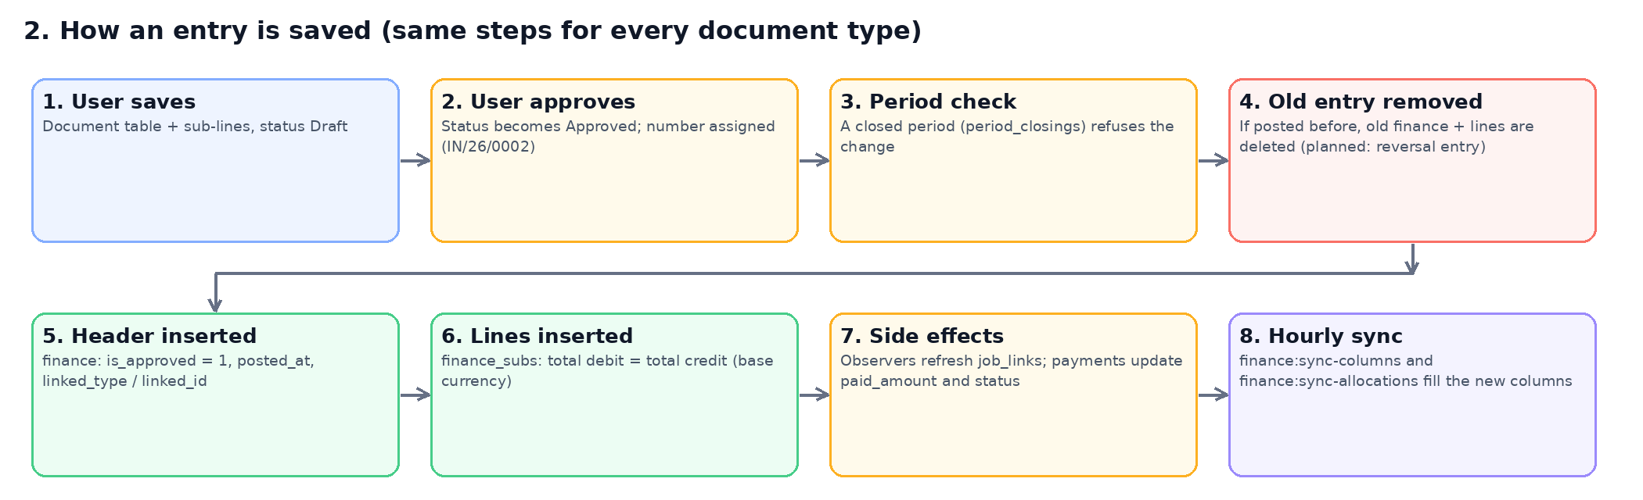
Step | What happens
1. User saves | The document is saved in its own table with its sub-lines (for example customer_invoices and customer_invoice_subs) with status Draft. Nothing reaches the ledger.
2. User approves | The status changes to Approved and the final number is assigned (for example IN/26/0002).
3. Period check | If the date falls in a closed period (period_closings) the change is refused.
4. Old entry removed | If the document was posted before (an edit), its old finance header and lines are deleted. This is the current behaviour; the design replaces it with a reversing entry so there is an audit trail.
5. Header inserted | One row in finance: voucher number, voucher type, reference date, totals in document and base currency, is_approved = 1, posted_at, job, and linked_type / linked_id pointing at the source document.
6. Lines inserted | Rows in finance_subs, inserted in one statement: account, debit, credit, base debit and credit, customer or supplier, job, tax-line flag. Total debit equals total credit in base currency.
7. Side effects | Model observers refresh job_links and the job invoice summary. Collections and payments update the invoice paid_amount and status.
8. Hourly sync | Until the posting service exists, finance:sync-columns fills the new reporting columns (entry date, partner, tax, source) and finance:sync-allocations creates settlement rows for entries posted since the last run.

3. Posting by document
Exactly which accounts each document debits and credits, in base currency. The account ids are fixed in the code today (for example Accounts Receivable 1130 is account 5).
Document | Voucher | Posts when | Debit | Credit | Source link
Customer Invoice | CI | Approved | Accounts Receivable 1130 (invoice total) | Income account per line (e.g. 4160) and Output VAT 2130 | customer_invoice
Supplier Invoice | SI | Approved | Expense / cost account per line (e.g. 5110) and Input VAT 1150 | Accounts Payable 2110 (invoice total) | supplier_invoice
Collection (receipt) | CV | Approved | Bank or cash account chosen (received amount); Bank Charges 5260; Other Charges 5280 | Accounts Receivable 1130, one line per invoice settled | collection, collection_invoices
Payment | PV | Approved | Accounts Payable 2110, one line per invoice paid; Bank Charges 5260; Other Charges 5280; extra transactions | Bank or cash account chosen (whole amount going out) | payment, payment_invoices
Credit Note | CN | Approved | Income account per line and Output VAT 2130 (reversal) | Accounts Receivable 1130 | credit_note (against an invoice)
Debit Note | DN | Approved | Accounts Payable 2110 | Cost account per line and Input VAT 1150 (reversal) | debit_note (against a supplier invoice)
Expense | EV | Approved | Expense account per line and Input VAT 1150 | Bank or cash account chosen; currency difference account when rates differ | expense
Opening Balance | OB | Saved | Customer / supplier balances on 1130 / 2110, or any other account | Opposite side; one automatic balancing line on Owner Capital 3100 if needed | opening_balance
Payroll | PR / LV | Salary paid | Staff Salaries 5200 | Bank or cash; Employee Loan Receivable 1180 for loan deductions | payroll
Journal Voucher | JV | Never (gap) | - | - | Approving only changes the status. No finance entry is created.
Proforma / drafts | - | Never | Not an accounting event | Not an accounting event | Shown through job_links only

Worked example
Invoice IN/26/0002: 2,000 plus 15% VAT, then a receipt of 1,725 and a credit note of 575.
Entry | Account | Debit | Credit | Notes
CI IN/26/0002 | 1130 Accounts Receivable | 2,300.00 |  | Settleable line; carries the customer
CI IN/26/0002 | 4160 Service Income |  | 2,000.00
CI IN/26/0002 | 2130 Output VAT Payable |  | 300.00 | Tax line: 15%, output, taxable base 2,000
CV COL/26/0001 | 1120 Bank | 1,725.00 |  | Money received
CV COL/26/0001 | 1130 Accounts Receivable |  | 1,725.00 | Settles part of the invoice
CN credit note | 4160 Service Income | 500.00
CN credit note | 2130 Output VAT Payable | 75.00
CN credit note | 1130 Accounts Receivable |  | 575.00 | Settles the rest of the invoice

4. Settlement: invoice, receipt, credit note
Outstanding is never typed in. It is the invoice line minus every allocation made up to the date you ask about, so the balance on any past date can be reproduced.
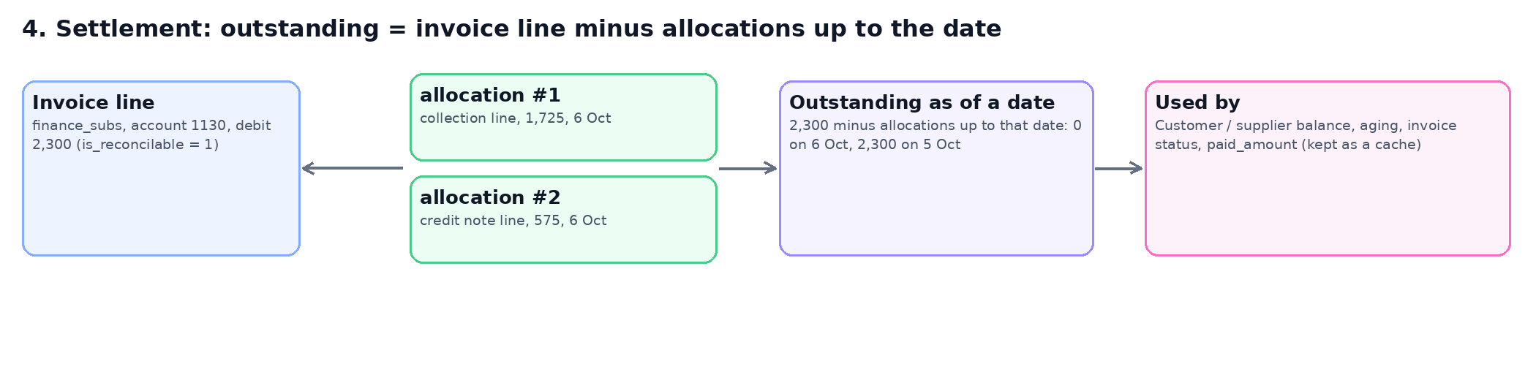
Where the allocation rows come from today:
- collection_invoices: the receipt line settles the customer invoice line.
- payment_invoices: the payment line settles the supplier invoice line.
- credit_notes.invoice_id and debit_notes.invoice_id: the note line settles the invoice line.
- Planned: reversing a receipt marks its allocation reversed from that date; earlier dates stay unchanged.

5. Tables and how they relate
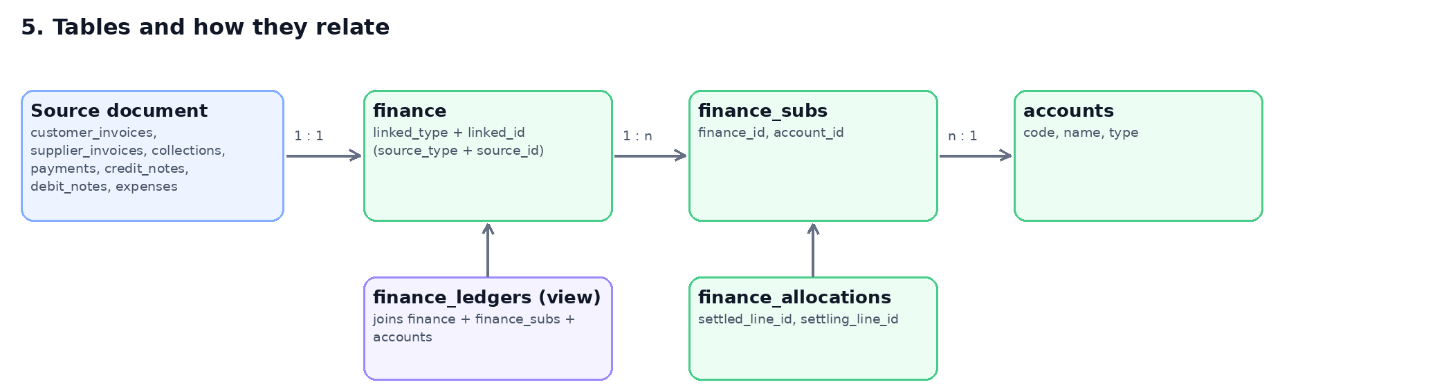
Table | Purpose | Key columns | Notes
finance | Journal entry header | voucher_no, voucher_type, reference_date, total_debit / credit (and base), is_approved, posted_at, linked_type / linked_id, job_id. Added: state, is_provisional, reverses_id, reversed_by_id, period_year / month, source_type / source_id | One row per posted document. Has many finance_subs.
finance_subs | Journal lines (the ledger) | finance_id, account_id, debit, credit, base_debit, base_credit, customer_id, supplier_id, job_id, is_tax_line. Added: entry_date, partner_type / partner_id, tax_code, tax_rate, tax_type, taxable_base, source_type / source_id, is_reconcilable | One row per account line. Belongs to finance and accounts.
finance_ledgers (view) | Reporting interface | finance_subs joined to finance and accounts: transaction_date, account_code / name / type, partner, job, tax, source, posting_status, is_provisional | Read-only. Posted entries only. Stores no data.
finance_allocations | Settlements | settled_line_id, settling_line_id, allocation_type, allocation_date, amount, base_amount, fx_gain_loss, status, reversed_at | Links two finance_subs lines: the invoice line and the receipt / note line.
accounts | Chart of accounts | code, name, type (Asset, Liability, Equity, Income, Expense), is_active, is_posting | Global (company empty) or per company.
collection_invoices, payment_invoices | Settlement records the screens keep | collection_id / payment_id, invoice id, amount | Source of the allocation rows today.
job_links | Documents per job | job_id, linkable (morph), doc_type, state, amount, paid | Kept by model observers; not part of the journal.
period_closings | Locked periods | company_id, year, closing_date, is_closed | Checked before a document is saved or approved.

6. Which report reads what
Report | Reads | Status
Trial Balance, Profit & Loss, Balance Sheet | finance_ledgers (one grouped query) | Switched
Tax Summary, Input Tax, Output Tax | finance_ledgers: tax lines on accounts 1150 / 2130 | Switched
Supplier Ledger | finance_ledgers, payable account 2110 only. Fixes the old always-zero balance. | Switched
Customer Statement, Supplier Statement | finance_ledgers: receivable 1130 / payable 2110 lines of the partner (same numbers as before) | Switched
Customer / Supplier Aging and detail screens | finance_allocations as of the chosen date: receipts, payments and credit / debit notes; reversals honoured | Switched
Job Balance (screen, cards, export) | Actual income = posted customer invoices minus credit notes, cost = posted supplier invoices minus debit notes, VAT excluded (finance_ledgers by job) | Switched
Provisional Report | Provisional = proforma invoices and expenses (documents, VAT excluded); actual = the books as in Job Balance; profit uses actual when it exists, else provisional | Switched
Job Income, Job Report | Stay on documents on purpose: Job Income is an invoicing view (approved versus draft, per invoice line, VAT-inclusive invoice totals); Job Report is the job list | Unchanged

7. What was done in the finance redesign
Everything is additive: nothing was dropped or renamed, and the old report code is still in place behind a switch (FINANCE_REPORTS_USE_LEDGER=false in .env restores the old queries).
Phase | What | Command / file | Status
0 | Baseline: read-only integrity checks (entries balance, headers equal lines, control accounts, allocations, view parity) | php artisan finance:reconcile | Done
1 | New columns and 9 indexes on finance and finance_subs, unique voucher number, line-to-entry foreign key, backfill | migration 2026_10_22_000001; finance:sync-columns (hourly) | Done
2 | finance_allocations table, filled from collections, payments, credit and debit notes | migration 2026_10_22_000002; finance:sync-allocations (hourly) | Done
3 | finance_ledgers view and read-only FinanceLedger model | migration 2026_10_22_000003 | Done
5 | Trial Balance, P&L, Balance Sheet, Tax reports and Supplier Ledger read the view; old-versus-new parity command | finance:report-parity; FINANCE_REPORTS_USE_LEDGER | Done
5b | Customer / Supplier Statement and Aging read the ledger and allocations | finance:report-parity; LedgerReports::settledAsOf | Done
5c | Job Balance and Provisional Report read actual income and cost from the books (VAT excluded); Job Income and Job Report stay document based | finance:job-compare; FINANCE_JOB_REPORTS_BASIS=documents goes back | Done
6 | PostingService: one place that posts, reversal entries instead of delete-and-reinsert, allocations written at posting time, journal voucher posting | - | Pending
7 | Clean-up: paid_amount as a derived cache, NOT NULL and foreign keys, stop writing linked_type / linked_id | - | Pending
Result on local data: 630 old-versus-new report comparisons with 0 differences (including every customer and supplier statement); a Trial Balance went from 137 queries to 2. Run finance:report-parity on production data before relying on the view there.

8. Known gaps and open decisions
Item | Detail
Journal vouchers never post | Approving a journal voucher only changes its status; no finance entry is created, so manual journals do not reach any report. Needs a poster (phase 6).
Account ids are fixed in code | Receivable 5, payable 18, Input VAT 7, Output VAT 20, bank charges 54 and others. A company with a different chart would post to the wrong accounts. Planned: company account roles.
Edit means delete and re-insert | Editing an approved document removes its entry and writes a new one, so there is no audit trail. Planned: reversal entries.
Job Balance profit included VAT (fixed) | Job Balance used to add invoice totals including VAT on both sides, so profit was overstated by the net VAT (job JOB-26-0010: 575 against 350 in the books) and counted draft invoices. It now reads the books, VAT excluded. FINANCE_JOB_REPORTS_BASIS=documents shows the old figures.
Aging ignored credit notes (fixed) | The old aging counted receipts only, so an invoice settled by a receipt plus a credit note still showed the credit-note part as overdue (invoice 32: 575). Fixed by reading allocations.
Provisional expenses (rule applied, please confirm) | An expense posts to the ledger (EV) and is also the provisional cost on the Provisional Report. Rule now used: an expense is the provisional estimate until the supplier invoice arrives, so job actual cost counts supplier invoices and debit notes only, never EV. Trial Balance and P&L still include EV. Please confirm this is how you work.
Posters do not fill the new columns | Until phase 6 the hourly sync fills entry date, partner, tax and source; meanwhile the view falls back to reference_date.
base_paid_amount on invoices | Shows 575 on invoices fully paid at 2,300. Unexplained and separate from the ledger.

9. Commands
Command | Purpose
php artisan finance:reconcile | Integrity checks, read-only: entries balance, headers equal lines, control accounts, allocations, view parity.
php artisan finance:report-parity | Runs each switched report the old way and from the view and compares the numbers, read-only.
php artisan finance:sync-columns | Fills the new reporting columns for entries posted since the last run (scheduled hourly).
php artisan finance:sync-allocations | Creates missing settlement rows (scheduled hourly).
php artisan finance:job-compare | Per job: Job Balance report figures next to the books figures, read-only.
/finance-entries/workflow | This document as a live page in the app, with current row counts.

